 ***Southwest***

***Software Development Team***

**Web and Database Design**

**CA2 - Due date: 23/4/2012**

**Band Website**

**Land Lovers**

***Design Document***

**Design & Development Team:**

**James Madden: X00086390**

**Shane Murphy: X00085315**

**Maciej Macierzynski: X00086366**

Table of Contents

Executive Summary 3

Statement of Purpose 4

Content Outline 5

Experiential Flowchart 5

Interface Mockups 5

Media Inventory 6

Table of Figures

Figure 1 Experiential Flowchart 6

Figure 2 Proposed Main Page 7

# Executive Summary

Land Lovers are a band from Dublin in Ireland, who plays in a melodic, wordy style that might not be actual pop music but is something of the sort. Formed in 2008 by Pádraig Cooney, who self-released the album Romance Romance, the full line-up now includes Cooney, Ciarán Canavan, Brian Lynch, Cormac Hughes and Shane Murphy.

They helped to found the Popical Island collective with fellow DIY-pop enthusiasts, formalising a co-operative relationship that had built up over time. The collective is now home to the likes of Tieranniesaur, Yeh Deadlies, Squarehead and Groom. It has become a one stop shop for all that is pop in Ireland. Land Lovers play a central role in its various undertakings.

The band has released the Immovable Feet EP; contributed songs to the much-loved Popical Island #1 and Popical Island #2 compilations; played wherever the need is greatest, including appearances at Electric Picnic and Forbidden Fruit; and released a limited-edition 10-song Yuletide Miscellany as well as writing and recording as part of the Popical Island Showband in Popical Island: A Hard Old Station.

Land Lovers’ new album Confidants has been released. The release was marked by a successful launch gig at a packed Crawdaddy (Harcourt St., Dublin) on Friday, 30th September, with support from Squarehead and Last Days of 1984. The album is the result of several short bursts of recording with producer Ciarán Bradshaw, and has been taking shape in the head and in the rehearsal room for roughly 18 months. It is be available on download, from iTunes, Bandcamp, eMusic, etc., and on CD from selected record stores, including Tower, RAGE and HMV Grafton St. in Dublin, Plugd in Cork and the Bell Book & Candle in Galway.

The album has attracted a considerable amount of praise. It was described as an “accomplished and rich record of tightly arranged songs” by Nialler9.com, who went on to remark that “Cooney’s profuse lyrics are a big highlight... The delivery of overtly foreboding themes is balanced out with exuberance and charm-filled songs”. The album has filled many Irish blogs “top albums of 2011” and “top songs of 2011”.

This exuberance is also noted by Hot Press, who also highlighted the band’s lyrical acumen: “with each new track, Cooney slips into a peculiar new character, all carried out with admirable flair”. Hot Press pointed out that the album can be listened to as something of a treasure-trove of pop history: “Confidants is a proud miscellany of decade-spanning pop influences”.

For AU Magazine, the album is a statement of intent: “Land Lovers are the latest indie-pop band to make waves on the Irish underground and with good reason –their new album Confidants is a sparkling listen.”

Metro Herald noted that “Confidants arrives spilling at the seams with quirky melodies, endearing guitar hooks and sun-kissed harmonies-Land Lover are worth getting into a tizzy over”.

“What really makes this album such an interesting listen“, for ListenBeforeYouBuy “are the stories embedded in the songs. The musicianship is executed very well, but the staying power of these tracks is in the deftness with which Land Lovers convey a true sense of life: a slice of their hearts seems contained in these songs.”

The impression left upon TheStreetLampDoesntCast leaves them thinking “Land Lovers manage that unique musical trait of taking a big sound and making it intimate… They manage to take what sounds like a whole orchestra of instruments and reduce it to a garage band roll…without losing any of its drama or cadence”

Tracks from Confidants have been picked up and received extensive radio airplay throughout the UK and Ireland by the likes of BBC Radio 6, BBC Radio 1, Q Radio, 2FM, Today FM, Phantom, BFBS, Amazing Radio and Further afield from AndHowFM and various College Radio stations.

# Statement of Purpose

To provide information for people with an interest in the band and make available contact information in order to open the lines of communication, allowing visitors to make contact and ask questions or request booking information.

To provide a central space in which visitors can access all information about the band, whether that be, Gig listings, band background/biography, up to date news, back catalogue, contact information and links to the bands social networking sites

The site will focus solely on the band but will provide links to affiliated labels and collectives. It will not sell merchandise directly, but buy links will be located on the site.

Visitors will be fans of the band, journalists, A&R personnel and anyone with an interest in the band.

Visitors will most likely be accessing the site in order to get information about the band, media or contact information.

Most requested content such as Biography, Contact Information, Media and past releases will be available from the main menu in one click. Current news and gigs will be listed on the home page for instant access.

The purpose of the website is to “Inform” the user.

# Content Outline

* News
  + News Feed
  + Twitter Feed
  + Gig Listing Feed
* Biography
  + Brief biography and back story
  + Press Pack Download
* Discography
  + Album Artwork
  + Track listings
  + Lyrics
* Contact
  + Media Contact Information
  + General Contact Information

## Experiential Flowchart

Macintosh HD:Users:shanemurphy:Dropbox:College:Semester4:WDD:CA2:Documentation:FlowLayout.ai

Figure 1 Experiential Flowchart

# Interface Mockups

Each page will be consistent and follow the same overall design layout. The content area should be the only area which visibly changes. The layout is designed to follow the user’s eye as they enter the page, starting with the logo on the top left, navigation top and centre, and finally content in the centre of the page. The content area will always be in the centre of the screen regardless of screen or window size.

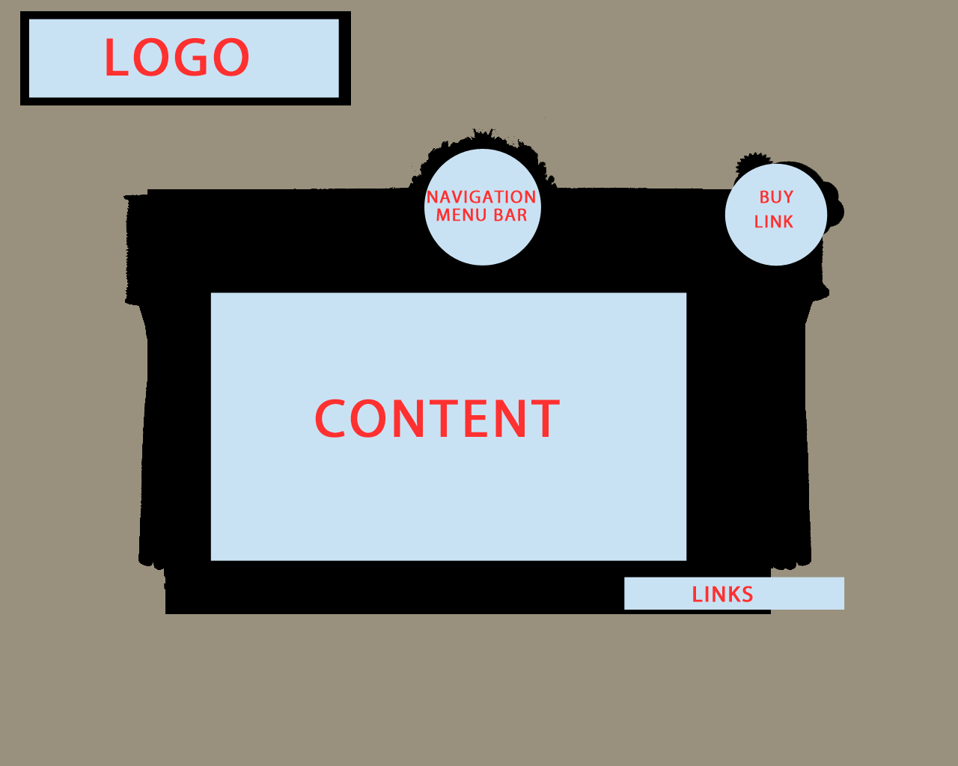

Figure 2 Proposed Main Page

# Media Inventory

The media content available on the site is embedded using the functionality of websites such as YouTube, Bandcamp and Last.fm. The copyright for all media hosted and embedded on the site is owned by Land Lovers including but not limited to all audio content, video content, images and design.